18 Advanced Techniques to Virally Supercharge
Your Opt-In Signups & Skyrocket Your List
without Breaking the Bank…

Welcome, and thank you for taking the time and effort to read this. If you follow through and use any of the techniques I’m going to explain, you will see real results—more signups. The formula is simple: the more techniques you use, the more signups you’ll get! If you use all of them, you will be amazed by the number of new signups you get everyday!

I also want to congratulate you. If you’re reading this, you’ve at least learned the #1 rule in online marketing: The Money is in the List! (You’d be surprised how many people are trying to make money online right now that have no idea they should start with a list. In fact, I used to be one of them—it took me 6 months to learn that!)

So, getting to the point…

You know you’d make money IF you had a huge list, you WANT to build it, but so far you’ve only been trickling in new subscribers or haven’t even figured out where to start. Take a deep breath, because if you’re serious about building a great opt-in list you’ve come to the right place.

The simple truth in list building is that there are really only 2 ways to do it:

1) get your signup page in front of more people
2) signup a higher number of people who see the message

Getting your message out to more prospects is fairly obvious and the focus of most people’s list building efforts. Advertise & promote your site = get signups. This is certainly important, but it also can be costly.

Signing up a higher number of people is often overlooked and it alone can be the difference between success and failure. The way to do it is to test different web pages, signup forms, and tools. And keep testing until you’re sure you can’t do better. Remember that it’s FREE to get more visitors to signup, but it costs money to get more visitors.

Here’s a simple example of these 2 points:

If you get 1,000 visitors to your site and signup 10, you are converting 1%.
Now, you can pay for double traffic to get 2,000 visitors and get 20 signups,
OR you can test and tweak your campaign for FREE to get 20 signups from the same 1,000 visitors. Your cost per signup (VERY important) is ½ of what it was.

To take it 1 step further, assume you are going to sell a product for $35 which is pure profit. If 2 people out of every 100 signups buy it, you make $70 per 100 signups. Now, if you’re converting only 1/100 visitors to signup, you need 100x100 or 10,000 visitors to make 2 sales. If you are converting 2/100 visitors to signup, now you only need 50x100 or 5,000 visitors for the same 2 sales!

Can you see why it’s important to test & squeeze every possible subscriber out of your traffic?

If you were buying traffic at $10 per 1,000 visitors look at the difference:

10,000 visitors = $100 (1,000 x 10);
2 sales = $70, so you lose $30 (70-100)

5,000 visitors = $100 (1,000 x 5);
2 sales = $70, so you make $20 (70-50)

It can literally mean the difference between making and losing money.

Let’s look at 18 ways to get more subscribers (without breaking the bank!):

- Be Specific – You need to target a specific niche of customers and ONLY market to them. One of the biggest mistakes list builders make is trying to cast a wide net to capture as many signups as possible. This is flawed thinking because you cannot serve every market segment.

Imagine your car is a BMW (if it really is, all the better!) and you need to get a tune up. Which of the following mechanics would you bring your prized auto:

  - A1 Auto Body – “We fix all car problems for all types of cars”
  - AAA Auto Body – “We are European car specialists”
  - Tops Auto Body – “We are BMW experts. We ONLY work on BMWs”

They can all tune up your car, but chances are you’ll go with c. Why? Because you know your kind of car is the ONE thing they do, so you assume they will do at least as good a job as the others, if not better.

The same goes in marketing. Someone is targeting each specific niche. If you are too general, your prospects will signup with the person who specifically focuses on them.

Examples of target markets:

- Online marketers – BAD! WAY too general

- Online marketers who suffer from lack of traffic – better, but can still improve

- Online ebook marketers who use safelists to generate traffic and are not getting enough hits to their web pages – NOW we’re getting somewhere.

When you target like c, you can then use headlines to attract prospects like: “Selling ebooks using safelists but not making money? Free guide shows you how to make safelist subscribers beat down your door to get your ebook”

You will be using your headline like that against others who are using the too general approach with ads like: “Free guide to generating tons of traffic!”

Which would you rather signup for?

- Stay the course – when you start any online marketing campaign, it’s very important that you stick to the same central idea and work with it until you get results. Another major problem that kills many would-be marketers is trying to advertise or promote in a certain way and when it doesn’t work jumping to something else. For example this pattern happens all the time:

- Excited newbie advertises website or affiliate site

- after 50 hits and no sales switch to another product

- after 50 more hits and no sales switch again

- start to believe “This doesn’t work” or “There’s no money left to be made in Internet marketing.”

- Become frustrated and bitter, quit, give up on dreams of creating wealth

This happens all the time. The problem is, the learning in this business (and most success stories) comes from trial and error. It’s important to research and see what ads are working, what products are selling, and what approaches sellers are using to make money. But in the end, you need to stay focused on your target market, and TEST TEST TEST! Keep trying different headlines, offering different free gifts, trying different signup page layouts—but stick to the same target customer base until you make it work!

It starts very slowly at 1st, but if you have valuable info to offer and you stick to it, your results will continually build on themselves and you will create a huge list.

It took me 6 months to get my 1st subscriber! I started by trying to sell products to prospects and only months later did I realize I needed to capture signups 1st and gradually build trust to make sales. How many people do you think would quit before 6 months of no results? This is a key point that ALL online marketing pros have in common.

- Maximize your signup page – one of the most important things you can do to build a massive opt-in list quickly is to make sure your signup page is very powerful and effective. Nothing’s worse than driving lots of traffic to your site, only to find that no one is signing up. So here are some tips:

  - Put the signup box high enough on the page so the visitor does not have to scroll down to find it. Users are far more likely to signup if your box is right in front of them.
  - Include the phrase “We respect your privacy and Never rent, sell, or share your info. You will NOT get a bunch of unwanted emails.” People are very careful about sharing their info with anyone they don’t know. Give them reassurance and your signups will go up.
  - Use a photo or image of the ebook or software you are offering. Photos and images without question outperform those without them.
  - Setup an exit popup or fly-in ad to capture extra signups. When visitors leave your page, you can have a popup or fly-in ad try one more time to capture them as a subscriber. Use this ad to offer something extra or different, or use , “Wait! …” and restate the value of joining.
  - Add a “tell-a-friend” box at the top to allow visitors to send your page to several of their friends or colleagues and gain viral signups

Check out a couple of mine:
www.i-vault.biz/indexmagic.html
www.i-vault.biz/indexmagic33.html

- Monitor your results – this goes hand in hand with staying the course. While consistency is important, you need to confirm that what you’re doing is at least working, and then try ways to make it work better. Always be thinking of ways you can offer more in your product, different headlines you can use, and extra bonuses you can use to increase your results.

Track the results you’re getting with stats tracking software—it’s the ONLY way to know what is working and what’s working best. If you make a simple change in headline, don’t you want to know if it doubles your subscriber rate? Then you can use that headline everywhere, and expect double the signups! If you don’t have testing or stat tracking software, I recommend ProAnalyzer. You can see it here: Pro Analyzer

- Use Safelists – Safelists are simply ezine subscribers that agree to receive mail from each other, and most people think they are worthless because they don’t know how to use them. What kind of people signup for safelists do you suppose? Mostly online marketers who aren’t getting enough traffic or list signups—if you have ways to help them get more traffic or signups, do you think they’ll be interested? You bet! Here are the secrets to using them:

  - Use lots of them – safelists will give you fewer responses per 1,000 prospects than many other forms of advertising. However, because most are free and you can sign up for as many as you want. You want to reach at least 100,000 safelist subscribers because you’ll only get 1 out of as many as 10,000 to reply. BUT, you can also mail members often—some are daily, some every 2-3 days, and some weekly. NOTE: Use an email address for signing up that is NOT your primary email because you’ll get 1,000s of messages. You also need to clean out the inbox often because if emails sent to you bounce, your account will be suspended.

At even 100,000 you can still get 10-50 new signups per week—not bad for FREE!

  - The #1 key in safelists is the headline. Hands down, because so many emails are sent out to members each day, your headline WILL determine your success with them. Test different headlines and track the results. When you find a winner, you can keep sending it out because safelists add new members every day. This can be a great source of signups for your list.

  - Consider upgrading to Pro memberships for those lists that give you results as a free member, or if they have 15,000 or more members. Many safelists allow Pro members to not receive emails from free members (only from other Pro members). Simply, the Pro members have a track record of spending money (they upgraded to Pro), and those members are more likely to be buyers for you, too!

HOT TIP: The best way to email 100,000+ safelist members is by using at automated emailing tool. You can do them all manually, but you’ll spend hours on it. There are several tools that allow you to input the safelist web address and your login info, and it will automatically send your emails to ALL of them with 1 click!

It takes a few hours to get all of your lists entered into it, but then you can schedule the software to automatically send your emails out everyday and watch signups come in! The tool I use is SMASS, and you can find it here: Get SMASS

Another automated tool I use is My Mad Mailer. You can email 1,500,000 weekly through a web page interface, test different ads, and track URLs all in one. Get it here:
My Mad Mailer

- Use Traffic Exchanges – traffic exchanges, when used correctly, can also give you a great boost in building your list. Remember that most traffic exchange users are looking for more traffic, so if you target them with ways to increase traffic, do you think they’ll be interested? Of course!

The best way to use these exchanges is to signup for one manual exchange that requires visitors to click a button to see the next ad—they actually need to pay attention to the ads they see to get credits. You also want to be sure that your manual exchange gives you credits for referring their service, even if referrals don’t sign up—this is the key point. I use HitPulse as my primary exchange. You can signup through this terrific free service called Profit Rally that acts like a portal to dozens of site promotion methods. Signup free here: Profit Rally

The next step is to signup for several automatic traffic exchanges (you just pull up the web pages and get credits just for leaving the browser open—you don’t even need to look at the pages. If you setup several of those automatic exchanges and use your REFERRAL URL from Hitpulse as your site with them, you will gain free credits at Hitpulse. Free credits there are useful because you can advertise your list signup page and you’ll get signups! Some popular autohit exchanges are autohits.dk, 126hits.com, freeautosurf.org, autohits.info, and autosurf.org

- Ip2IP Instant Messenger – this is a breakthrough tool most people don’t know about. It allows you to send popup messages directly through other people’s computers, even if they aren’t looking at your web page!

The best part is, you can blast 1,000s at a time, and it is NOT considered SPAM. This is a revolutionary new technology—you type in your message and a range of IP addresses, and the program goes to work to try each one—popping up a little system message on each user’s computer. No competition, no cost to do as often as you like!

The best way to use this tool is to work with a short & simple ad (text only) that gets viewers to click on your web page link. Have your webpage convince them to signup for your list.

BONUS! This software is currently selling for $29-$99 online depending upon where you see it. I am showing you how to get a Free Trial.
Click here: IP2IP Messenger

- Link Machine (SEO Optimization Tool) – this is a REAL Search Engine Optimization tool you can try for free. It doesn’t try to “trick” search engines or give you short term gains in rank. It helps you optimize your site by comparing it with the top sites for any keywords you choose. So even if Google changes their criteria for ranking, you will always be able to optimize your site and get a high rank. It also sets up link exchanges for you with 1,000s of other sites with high page ranks—that is the key in getting a high rank!

The top sites in every search word get 1,000s of “free” hits every week—you can absolutely explode your viral list building “system” with a high ranking site. Many products and services offer “black hat” methods of quickly moving up the ranks in search engines, but black hat methods essentially “trick” the search engines temporarily. That means your site will shoot up in ranking, then plummet back to where it was soon after.

Search Engines are the #1 most popular way Internet users find sites, so getting a higher ranking will bring in more traffic and subscribers. Click here: Link Machine

- Use Magic Subscriber – this is an amazing, simple tool that really works! It is a unique, “system-looking” popup that allows visitors to subscribe to your mailing list without typing in any info! It automates the process so users just need to click “Subscribe” and it does the rest. I tracked my results, and I have gotten 2x as many signups by using that tool. It takes 5 minutes to setup, and it works perfectly.

I use this tool on my home page and also my ad pages when I advertise them directly. It is much easier for people to sign up with it, so more of them do! With ad pages, once a visitor leaves the site you’ve lost them and wasted the ad money unless you capture their info. Magic Subscriber is the best tool I’ve found so far.
As a Special Bonus, you can download it FREE, here: Magic Subscriber

Here’s one I use:

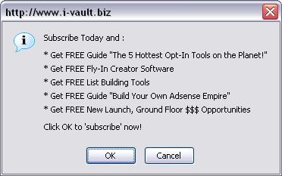

- Pay-per-Click – this advertising method can really help to skyrocket your list if you use it right. The basics of pay-per-click are you bid an amount you will pay for each click of your ad. When visitors click your text ad, they go to your web page. The great thing is, you only pay for those who are interested and click on your ad. But if you don’t use it right, you can run up a big bill very quickly, and have nothing to show for it.

I recommend using GoClick.com for a low-cost PPC solution, and Google Adwords and Yahoo Search Marketing if you have a little more to invest. I advise AGAINST using Brainfox.com because although prices are cheap I ran campaigns with them and got 0 responses for the same campaigns that were working great at the others.

You can visit their websites and signup for an account, but you absolutely HAVE to track results with PPC to know what’s working. Again, I use ProAnalyzer but any stats tracking that can rotate multiple web pages, tell you how many clicks, how many signups from those clicks, and how many sales also will do. That way, you can see exactly which ads and headlines pull the best, and tweak for best results.

When you write PPC ads remember one thing:
Be VERY specific with your wording so ONLY QUALIFIED prospects click your ad.

For example, if you are adding signups to your list and your target prospects are safelist users, avoid general ads like “Double Your Traffic.” You will get clicks from all sorts of people not interested in Safelists. Instead try, “Secret Technique Doubles Response from Safelist Advertising.” Much better—now people know BEFORE they click that you are talking about safelists.

And the same goes for choosing keywords to bid on. When you bid on keywords, your ad shows up anytime someone searches for those words online. Avoid too general words like “traffic” and get very specific “increase safelist traffic” because often the more specific the word, the less it will cost to get the top bid.

Perfect PPC bidding strategies are beyond the scope of this but that will get you going the right way. You can find advanced resources specifically for PPC if you are interested in becoming an expert.

- Tell-a-Friend – this is the foundation of all viral tools, and you need to put one on the top of your web page ASAP. Many products are available that allow you to put a link on top of your web pages users can click. It opens a box where they can type in several friends’ and colleagues’ names and email addresses. Each of the people they type in get a personalized email FROM someone they know with a recommendation to look at your site. Free promotion, and word of mouth is the most effective promotion you can get, without question. The trick to tell-a-friend is you have to offer enough value for them to want to send to their friends (What would it take for YOU to do that?)

The tool I recommend and use is Tell-a-Friend-King. This one allows you to customize a button to place on your web pages, and it opens a very user friendly TAF box. It’s very simple and very cheap, and it also tracks all of your results! (We’ll cover 2 more advanced uses for the TAF feature below also…)

- Funny Videos – did you ever get a funny video clip forwarded to your email from a friend or colleague? These videos spread virally like wildfire! The trick to getting signups out of it is to put your signup page below the video on a web page, and include a “Tell-a-Friend” box so visitors can easily email the funny video (and also your ad) to up to 10 friends. Look at an example here:

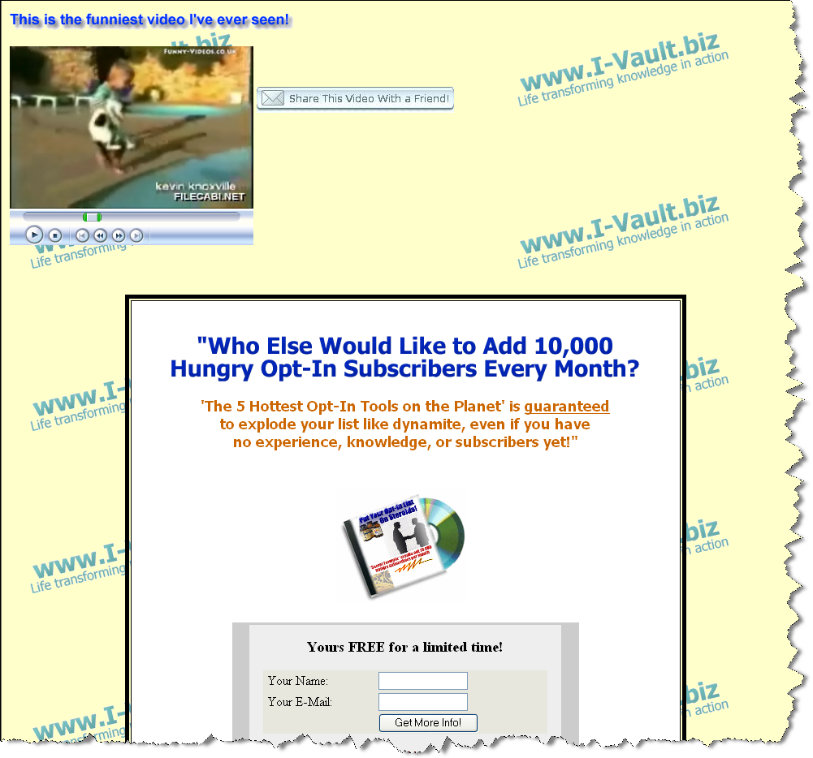

Believe me, these work! One person emails 3 or 4 people they know, who also email a few they know… Not everyone will sign up for your list, but enough will and the entire promotion is FREE! You can download free clips that are legal to use (public domain) here: www.funny-videos.co.uk

NOTE: always verify the fact that you have permission to use any materials. As of this writing that is true, but it’s always better to confirm. To embed these videos into your webpages, check with the software you use, but an example is this simple one line:

<embed src="babyvcat.wmv" align="middle"></embed> </noembed>

This works for Macromedia Dreamweaver, and you insert the HTML after the <head> tag but before </head>. Then your video appears at the top of the page.

If you need a tell-a-friend service, I highly recommend Tell-a-Friend King. It’s very easy to use, they handle all of the setup and maintenance, and the cost is very low. Visit them here: Tell-a-Friend-King

- Use Viports – Viports are viral reports. You can create a free info report with something of value to your prospects, compile it into a Viport, and give it away. In order for recipients to open the file, they need to enter 3 names and emails to unlock the file. It’s a great way to build a viral list, fast! In case you don’t have a Viport creator, download one FREE here: Viport Creator Here’s an example:

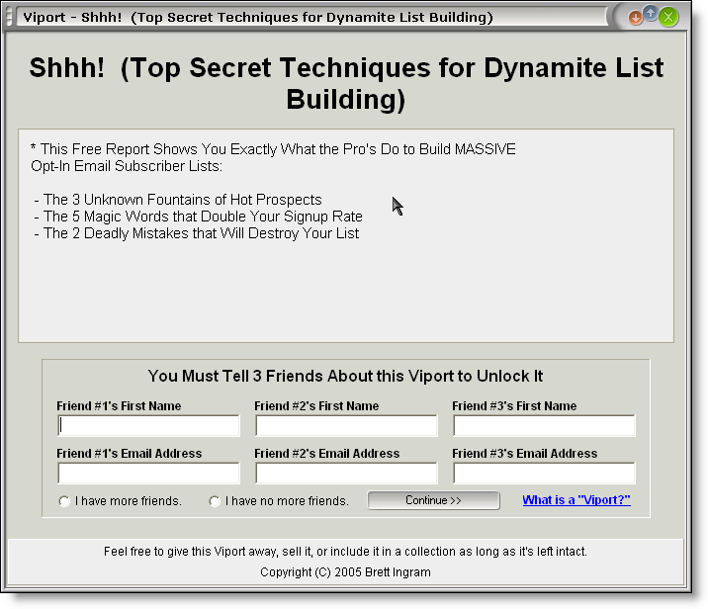

- Create a Blog – Blogs are a great indirect way of really building credibility online. A blog is a Web log, or basically a journal you keep online. As opposed to a traditional website, you create posts to a blog with messages that are dated (much like online forums). The value with these is in creating a targeted blog and providing lots of great content about the subject. If you are able to do that, you will gain a loyal subscriber base that checks in often, posts messages, and refers others. You also gain a lot of credibility in the “anonymous” online marketing world. Check out the new Blog I just started at www.optin-email-list.com

If you don’t feel you know enough about a subject, search online for sites on your topic, and email the site administrators to ask them to contribute an article or do an interview. Also, post any useful tools, software, guides, and reviews of products. They key to blogs is to put lots of good content, and to UPDATE OFTEN (daily if possible). People will only continue to visit as long as fresh content is there. If it gets stale, you’ll lose your visitor base.

This may seem like a lot of work, but I can promise you that you can create a huge list very fast if you put some time into it. Also, it’s one of the few online promotion activities you can actually do almost free.

To get started, visit www.blogger.com to start a FREE blog. Blogger will even host the blog for you, so you don’t need to pay anything!

HINT: If you are serious about starting a blog, check out this resource. It shows you how to directly make money from your blog, without spending any money and without selling anything! This is an awesome resource for blogs with good content that are updated often: Google Adsense Secrets

- Top Sponsor Ads – Another hidden gem. These are the short text ads you see on the very top lines when you open some emails. It’s the first thing the reader sees when opening email, and the best part is most people don’t know about them AND they are very cheap.

The best part about Top Sponsor Ads is that they are counted by opened emails, NOT sent emails. So, if you get 10,000 impressions that’s 10,000 OPENED emails where your ad is seen. Here’s an example from an email I received:

Top Sponsor Ad:
EXPERT SoftWare & EXPLOSIVE Leads!
300 THOUSAND Leads a WEEK!
http://tinyurl.com/dcdd9
----------------------------------------------------
(The email message starts down here…)

The best way to use these ads is to tease the reader to create curiosity and get them to click your link. Your ad needs to grab readers and promise something valuable to them. Remember your audience: these email readers are all building lists and trying to make money online. Two sources for Top Sponsor Ads are MBP Advertising and Business World List

- Write testimonials – a great way to get free traffic and free signups. Any product or service you try that impresses you (even free mini courses or ebooks), email the author with a testimonial and state in the email that you give permission to publish it. ONLY do this for products and services you really believe in, though. Your reputation in online marketing is your most important possession, so don’t risk it just to get free promotion. The way to get these published is to write specifics about what you like and how you benefited from it. A couple lines of general praise will not get you published. Here are a few great examples (scroll down to the bottom of the page to see them): Testimonials

It is a proven fact that testimonials that include the author’s web page and name get clicked on. You gain instant credibility because you are featured on someone else’s site, and you are saying something positive about their product.

- Start JVs – joint ventures are another way to go to get free promotion, and you can gain access to 1,000s of subscribers. Joint ventures are simply when one marketer promotes another marketer’s product to his or her list. So, if you ask marketers with huge lists to do a JV, you can both benefit with a ton of sales.

Obviously, the more successful the marketer, the more selective he or she is in terms of which products and services to promote. For this to work well, you must have a great product that’s valuable and not a rehash of someone else’s work.

Browse web sites on Clickbank or look at any ad pages you see promoted everywhere and look for the author’s contact info at the bottom. Email (or even call when appropriate) the author, request doing a joint venture and give 4-5 great bullet points about the value of your product. Also, include your product FREE for review—no reputable marketer is going to promote your product without knowing how good it is (nor are they likely to pay for it). The value of the promotion and sales you’ll get in return is far greater, believe me.

Promote it to several JVs and let them know you’ll only be accepting 2 partners and several are reviewing it (create urgency to act). Do this until you land a few JVs, and now you’ve also built successful relationships you can use again and again with your JV partners! Here is a great Joint Venture resource: JV Alert

- Viral page – I saved the best for last! This is one of the absolute BEST ways to get your list building to explode. It combines multiple elements from previous list builders and rolls them into one power-packed list building supercharger!

First, get your hands on a free gift that you know your prospects want. (The better the gift, the better the response). You may even want to consider buying a product that gives you rights to use it as a gift (most products will state whether you can give them away or not).

Next, you can promote the free gift to your list (if you have one), or using any other advertising or promotion. The goal of your promotion is to bring prospects to your web page.

What your page should include:
- Free product displayed right at the top, and use an image or picture if you can.
- Include some persuasive details to build up the value of the product
- Give step by step details about how to get the product free:

Step 1 – Click the Tell-a-Friend Button
(This is where you insert the button from Tell-a-Friend King)

Step 2 – Details on how to fill out the Tell-a-Friend form

Step 3 – Details on how to personalize the message so it comes from them to their referrals

Step 4 – Rules: you want to make sure they know the people receiving their email, and you want to prevent SPAM

Step 5 – Send message

When prospects complete the form, I instruct them to include 1 email address that I provide, and it is an autoresponder. They will fill out the form with their 3 referral names and my autoresponder, and when they send the email my autoresponder will reply with a copy of “Profit Pulling Niches.”

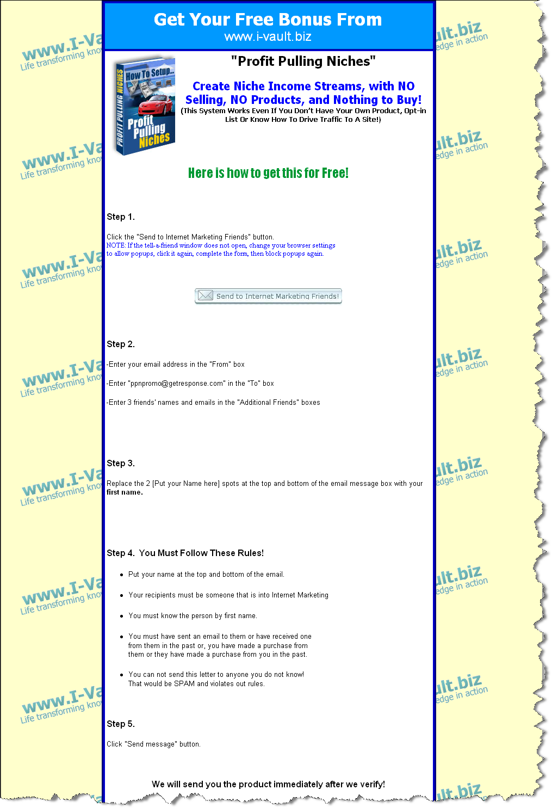

The tell-a-friend box from Tell-a-Friend King I setup like this:

Subject: This site made me think of you – Check it out!

Message: Hi, it’s me [Put your 1st name here]

I just wanted to tell you that I found this great website for opt-in list building and Internet marketing.

They also give some of the best Internet marketing tips & software I’ve ever seen. I think you’ll love it also and I wanted to share it with you! You can find them at:

www.i-vault.biz

Oh! They also give away an unadvertised bonus of “Profit Pulling Niches” (the #1 guide to making profits with Google Adsense—no products, no selling!) just for signing up.

This is the product they give you free: www.i-vault.biz/ppn.html

Remember, it’s only after you sign up! Just wait for the reply email they send you!

Thanks,
[Put your 1st name here]

Just promote the page through any advertising or lists you already have, and watch your list explode! You are giving something away that normally costs money, so there is automatically value in it. Now, some people will fill out bogus info and try to cheat the system. That’s okay. You will still create a tremendous number of new visitors to your signup page through these referrals, and a much higher number of them will signup also. In turn, they will refer people to get their free gift! Can you see the power in this???

Where to go from here:

I’ve shared many techniques with you about how to really explode your opt-in list. It may seem overwhelming or difficult to know where to start. My suggestion is start with the idea you like the best or feel best about, and run with it. Just start with 1 and keep it simple. Get it up and running, see the results, then maintain it and add another.

If you really use this information I can guarantee you will build your email list faster than you ever thought possible. But this info is only valuable if you do USE it. The difference between dreamers and winners is the ability to take action and follow through.

One more often overlooked, CRITICAL point: This business requires you to generate MOMENTUM—if you try something once and fail, then try something else, and keep looking for “the one BIG ONE” that will make you rich I have bad news—you will still be looking in 50 years. It’s not as much the opportunity itself or in this case the list building tool itself, as much as it is your persistence in working it and making changes UNTIL you get the result you want. Start with one and GET it WORKING! Then use as many ways to get traffic and signups as you can (setting up 1 at a time) until you’ve built enough momentum to allow your list and profits to grow automatically.

Make a plan and challenge yourself. Also, always feel free to contact me if I can help you. This is the greatest business in the world, but it can also be confusing and challenging at times. Let me know if you get stuck: admin@i-vault.biz (I answer all of my own emails).

Also, email me with feedback and let me know what you think of this ebook, and also what other topics you’d like more info about. Email feedback@i-vault.biz I may even use your feedback on one of my web sites, and I’d be happy to link it to yours.

To your success,


www.i-vault.biz (Life Transforming Knowledge in Action)
www.optin-email-list.com (#1 Site for Opt-in List Building)

© Brett Ingram. No reproduction, redistribution, or copying of any content in this report without prior permission from the author.

Your success using the information in this report is entirely up to your ability, persistence, and factors in your control. As a result, we make no guarantees of results or income from this report.

